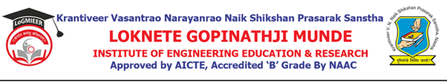
AD-301 | Activity Report | Academic Year: 2026-27
Rev-00 | Activity Report | Semester: III/VI
DEPARTMENT OF AIML ENGINEERING
Particulars | Description
Activity
  Academic Expert Talk
Activity level | Department Level
Title
  Awareness Program on Avishkar Competition
Speaker / Resource Person | Ms. Kashish Kazi & Ms. Saher Raje – Alumni, Department of Computer Engineering
Organized by | Department of AIML Engineering
Venue | Seminar Hall 123
Date & Time
  31/08/2026, 3:15 PM to 4:15 PM
Objectives of the activity | 1. To create awareness among students about the Avishkar Competition.  2. To explain the purpose, structure and participation process of the competition.  3. To motivate students to develop innovative ideas and projects.  4. To encourage students to participate in research and innovation activities.
Outcomes of activity | 1. Students gained awareness about the Avishkar Competition.  2. Students understood the participation process and requirements.  3. Students were motivated to present innovative ideas and projects.  4. Students gained interest in research, innovation and project development.
Targeted participants | SE, TE & BE Students – AIML Engineering
Total no. of participants, Participation % | 75%
Content of the activity | The session covered an introduction to the Avishkar Competition, its objectives, participation procedure, project presentation, innovation and research opportunities. The speakers also encouraged students to identify innovative ideas and actively participate in the competition.
Relevance to POs | PO1: Engineering knowledge – applying technical knowledge to develop innovative solutions.  PO2: Problem Analysis – identifying problems and developing innovative ideas.  PO3: Design/Development of Solutions – encouraging students to design innovative projects.  PO10: Communication Skills – presenting project ideas effectively.  PO12: Life-long Learning – developing interest in continuous learning, research and innovation.
Relevance to PSOs | PSO1: Apply AIML engineering knowledge and technologies to solve real-world problems.  PSO2: Develop innovative software/computing solutions through project-based learning and research activities.
Methodology used | Expert talk, presentation, interactive discussion, question-answer session and guidance by the resource persons.
Brief Description of the Activity | The Department of AIML Engineering organized an Academic Expert Talk on “Awareness Program on Avishkar Competition” on 31/08/2026 from 3:15 PM to 4:15 PM at Seminar Hall 123. Ms. Kashish Kazi and Ms. Saher Raje conducted the session for SE, TE and BE AIML Engineering students, with special emphasis on students who are in their final year and approaching graduation. The speakers created awareness about the Avishkar Competition, explained the participation process, and encouraged students to develop innovative ideas and participate in research and project activities. The session was interactive and helped students understand the importance of innovation and research for their academic and professional careers.
Geo- tag photos of the Activity
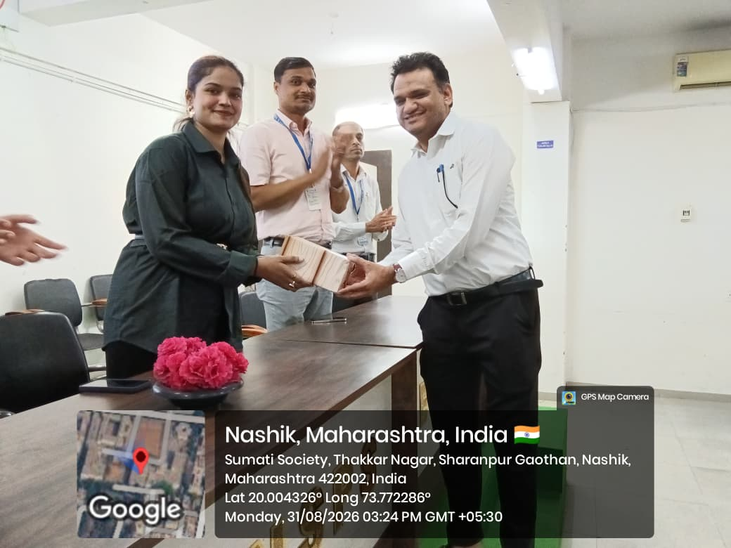
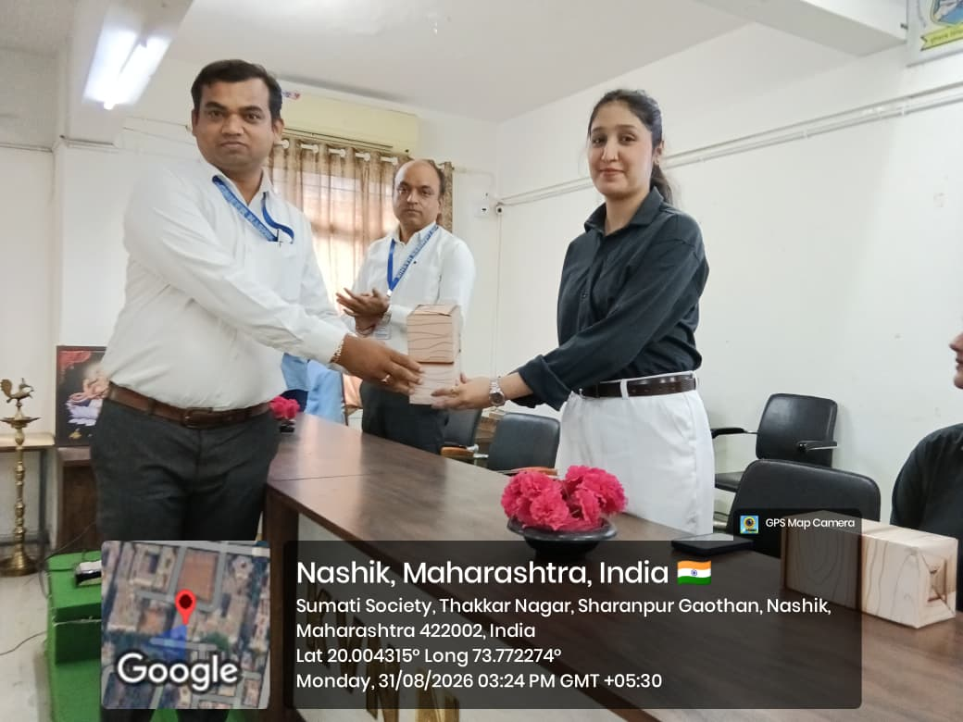
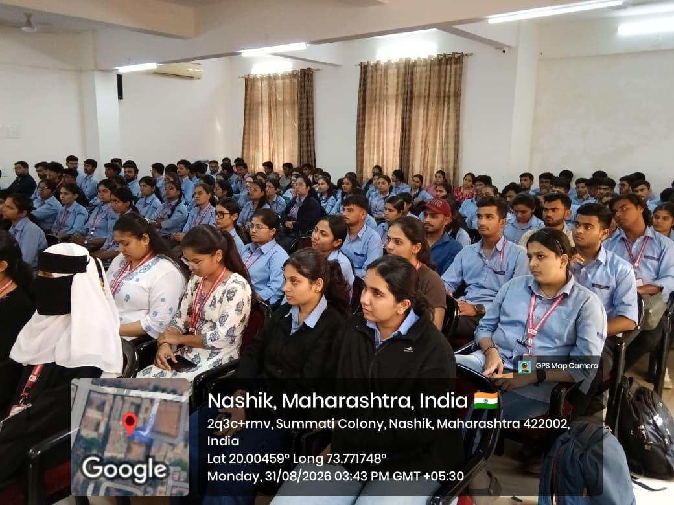
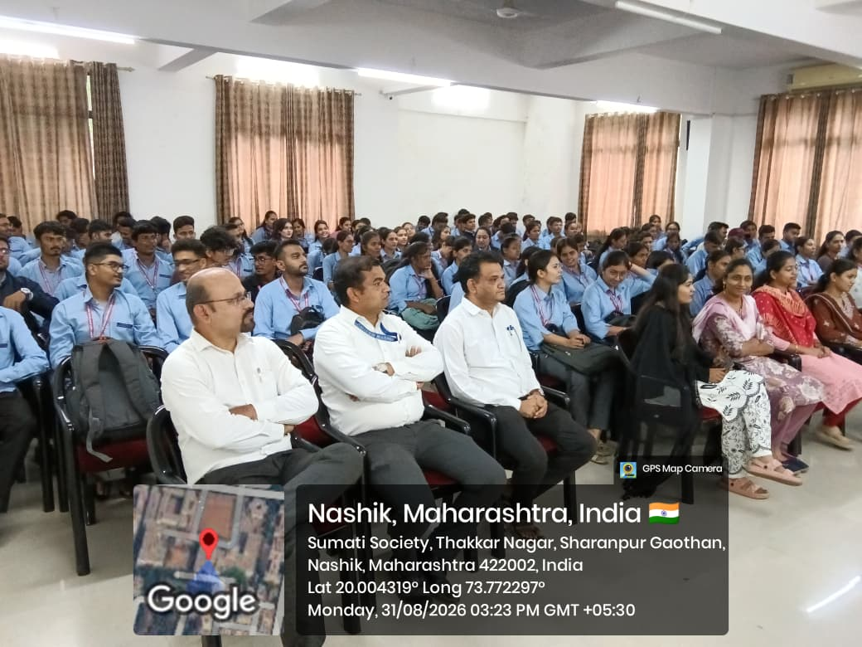
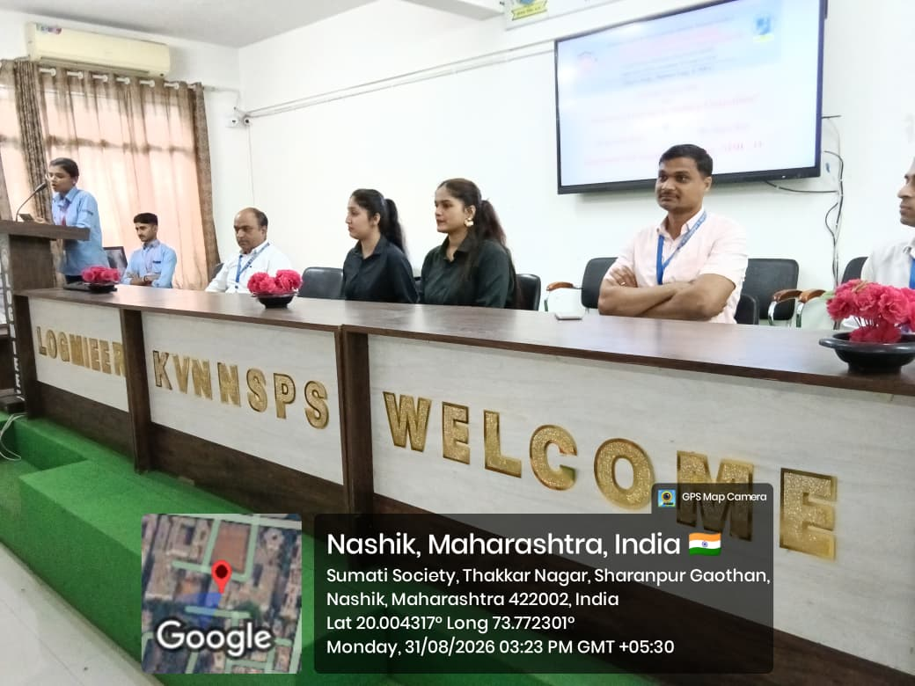

Prof.V.H.Date Prof.M.D.Sanap Prof.S.S.Punde Prof.N.V.Kapade
Activity Coordinator HOD Dean Academic IQAC Coordinator

